Application Note

Benefits of NANOPERM Cores and Chokes in Electronic Applications

Abstract: This application note highlights the advantages of cores and chokes based on nanocrystalline material in electronic applications. Nanocrystalline cores offer exceptional magnetic properties, low core losses, and high energy efficiency, making them an ideal choice for various EMC filter applications.

|  |  |  |  |
| --- | --- | --- | --- |
| Version | Date | Purpose / Change description | Autor |
| 1.0 | 22.11.2023 | Created | N. L. Figueroa |
|  |  |  |  |

Reproduction, publication and dissemination of this publication, enclosures hereto and the information contained therein without MAGNETEC‘s prior express consent is prohibited.

Disclosing the specification to third parties or using its content without written permission from MAGNETEC is strictly forbidden and every offender is liable to pay the corresponding damages.

# 1| Key Specifications

Ribbon cores made from Magnetec’s NANOPERM nanocrystalline band possess unique properties that make them highly suitable for electronic applications.

NANOPERM is a rapidly quenched, iron-based alloy with a fine nanocrystalline structure. This material has extraordinary soft magnetic properties, which can be precisely controlled by careful annealing of the band under external magnetic fields.

This application note explores the benefits of nanocrystalline cores and chokes in terms of their magnetic performance, efficiency, and overall system reliability.

|  |  |
| --- | --- |
| **NANOPERM nanocrystalline strip** | |
| **Parameter** | **Value** |
| Saturation flux density | 1.2 T |
| Coercivity (quasistatic, 50 Hz) | < 3 A/m |
| Saturation magnetostriction | < 0.5 ppm |
| Specific electrical resistivity | ~115 µΩ cm |
| Specific density | 7.35 g/cm3 |
| Curie temperature | ~600 °C |
| Operational temperature | -40 °C to over +200°C |
| Material losses (0.3 T, 100 kHz, sine) | < 110 W/kg |
| Ribbon thickness | ~17 to 23 µm |
| Grain size (typ.) | 10 nm |
| Permeability range | 1000 to 200000 |
| Alloy composition | Fe73.5 Cu1 Nb3 Si15.5 B7 |

# 2| Magnetic Properties

NANOPERM cores exhibit remarkable magnetic properties that enhance the performance of inductive components in electronic systems:

High magnetic permeability (𝜇𝜇): Permeability quantifies how responsive a material is to external magnetic fields. The higher the permeability, the larger the magnetization under a field. NANOPERM cores can offer significantly higher magnetic permeability compared to other core materials. This allows higher inductance and impedance values in common mode chokes, and smaller inductive components in general. This high permeability allows making smaller inductive components and better magnetic shielding elements.

High saturation induction (𝐵𝐵𝑠𝑠):

NANOPERM exhibits high saturation induction, allowing cores to operate at higher currents before saturation, where cores stop being effective. This allows for the design of chokes that are compact (with a smaller magnetic length) and that can operate at higher peak currents, or under a DC magnetic bias.

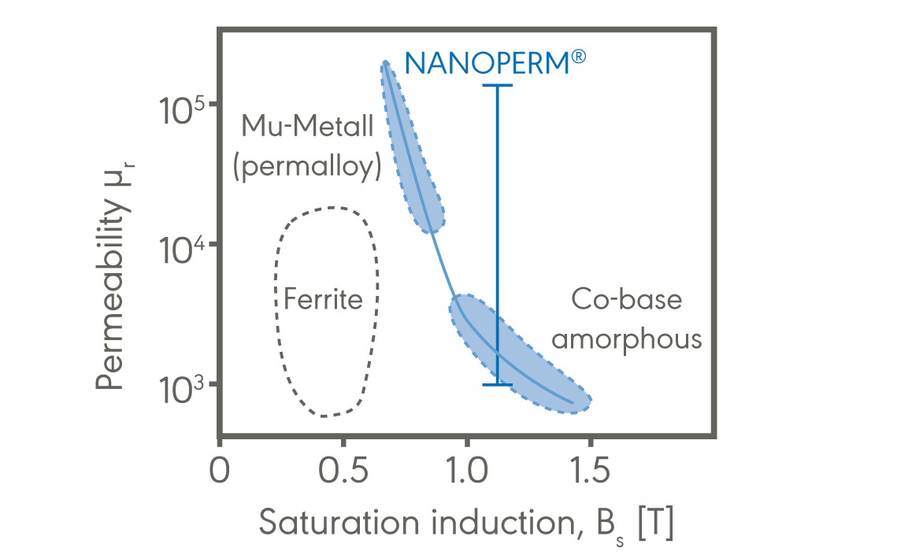

*Fig. 1- Typical initial permeability and saturation inductions for low magnetostrictive softmagnetic materials*

# 3| Low Core Losses

One of the key advantages of nanocrystalline cores is their remarkably low core losses, which result in improved energy efficiency:

* Hysteresis losses: Hysteresis is a form of magnetic friction, for a given maximum flux density, it gives rise to a power loss per unit volume that is proportional to the frequency and area under the hysteresis loop. NANOPERM has low coercivity, meaning it requires a small magnetic field strength to reverse magnetization, and therefore has a remarkably low hysteresis loop area and losses.
* Eddy current losses: As a magnetic flux develops inside the core, there will be an electromotive force (emf), described by Faraday’s law of induction (∇ × 𝑬𝑬 = −𝜕𝜕𝑩𝑩/𝜕𝜕𝜕𝜕), that gives rise to currents in the material. These currents contribute to losses, as the material is resistive. NANOPERM cores suppress these losses by having small laminations that are thinner than a human hair, ensuring proper behavior in the high frequency (1 to 100 MHz) regime. This is notable, as eddy current losses scale roughly ∝ 𝑓𝑓2.

For a rough estimate of the total power losses under sine-wave excitation in our NANOPERM cores, one can use the following empirical Steinmetz relation:

𝑃𝑃𝐹𝐹𝐹𝐹 ≈ �

𝑓𝑓

1.8

� �

∆𝐵𝐵

2

� 80 W/kg

100 kHz 0.3 T

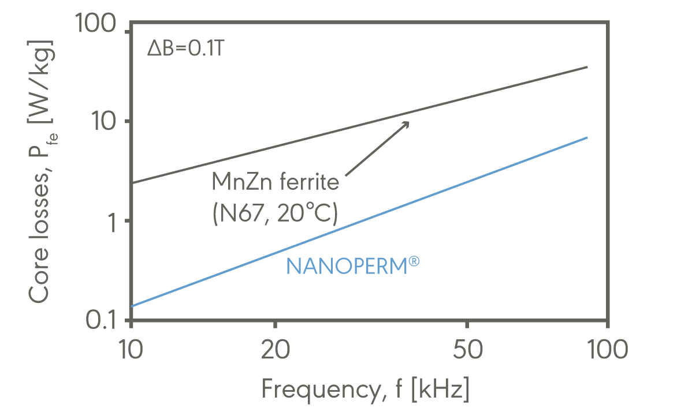

*Fig. 2- Core losses of NANOPERM are lower than for common ferrite materials.*

|  |  |
| --- | --- |
| **Application area** | **Application** |
| **Power supplies** | Push Pull SMPS transformer |
| Common mode choke |
| Current Transformer |
| Drive transformer |
| Magnetic amplifier |
| **Telecommunication** | Signal transformer |
| Common mode choke |
| **Sensors** | Earth leakage circuit breaker (AC sensitive) |
| Earth leakage circuit breaker (Pulse sensitive) |
| Current transformer |
| **Automotive electronics** | Common mode choke |
| On-Board Charger |

# 4| High Energy Efficiency

The combination of high magnetic permeability and low core losses in nanocrystalline cores contributes to enhanced energy efficiency in power electronic systems:

* Improved power conversion: Nanocrystalline chokes enable more efficient power conversion by reducing energy losses and increasing the overall efficiency of the system. This results in improved performance and reduced power dissipation.
* Enhanced system reliability: Lower energy losses translate into reduced heat generation, leading to lower operating temperatures. This improved thermal performance enhances system reliability and allows for the design of more compact and robust power electronic systems.

# 5| Wide Frequency Range

Nanocrystalline cores exhibit excellent performance across a wide frequency range, making them suitable for various power electronic applications:

* Broadband response: Nanocrystalline cores maintain their favorable magnetic properties over a wide frequency spectrum, enabling them to efficiently operate in both high and low-frequency applications.
* Compatibility with switching frequencies: Nanocrystalline chokes effectively handle high frequency switching operations, making them ideal for power converters, motor drives, and other applications that require rapid switching.

# 6| Other advantages over ferrite

In ferrite, the Eddy currents are suppressed because the resistivity of the bulk material is very high. However, the bulk material has high dielectric losses, and parasitic effects that are not present in nano-crystalline cores.

For example, the large dielectric constant can lead to dimensional resonances in a ferrite at a frequency determined by the ferrite dimensions, that makes them much worse after a given frequency.

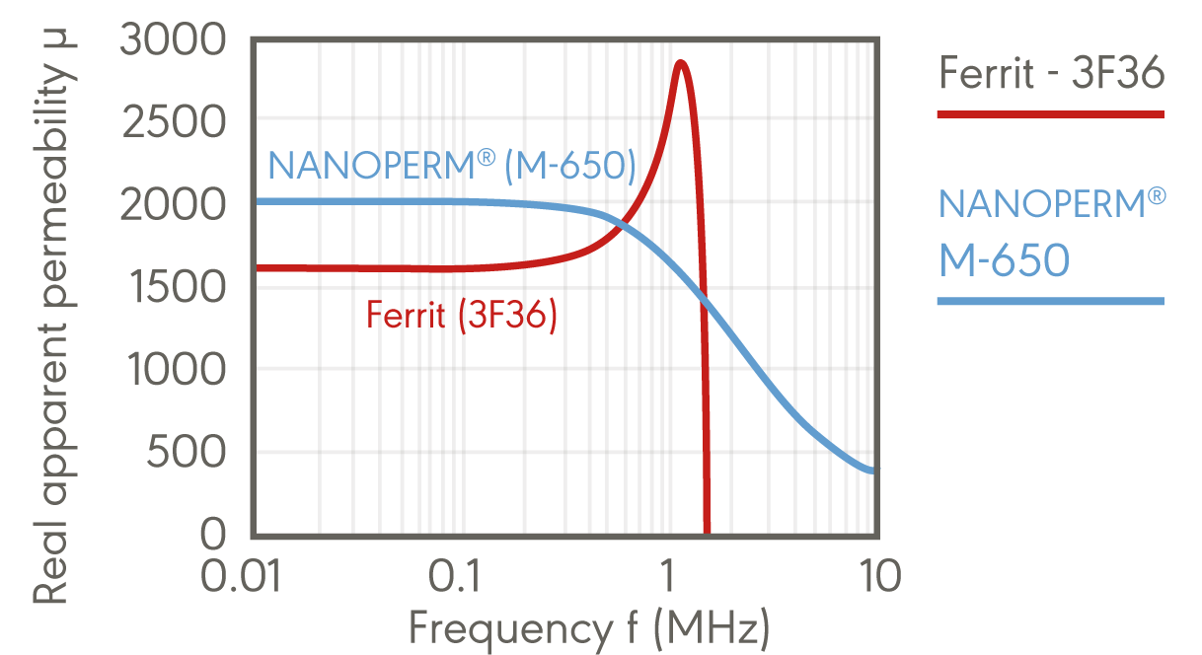

*Fig. 3- Permeability vs frequency for a 3F36 ferrite (with toroidal T80 geometry) and a toroidal NANOPERM core (toroidal M-650)*

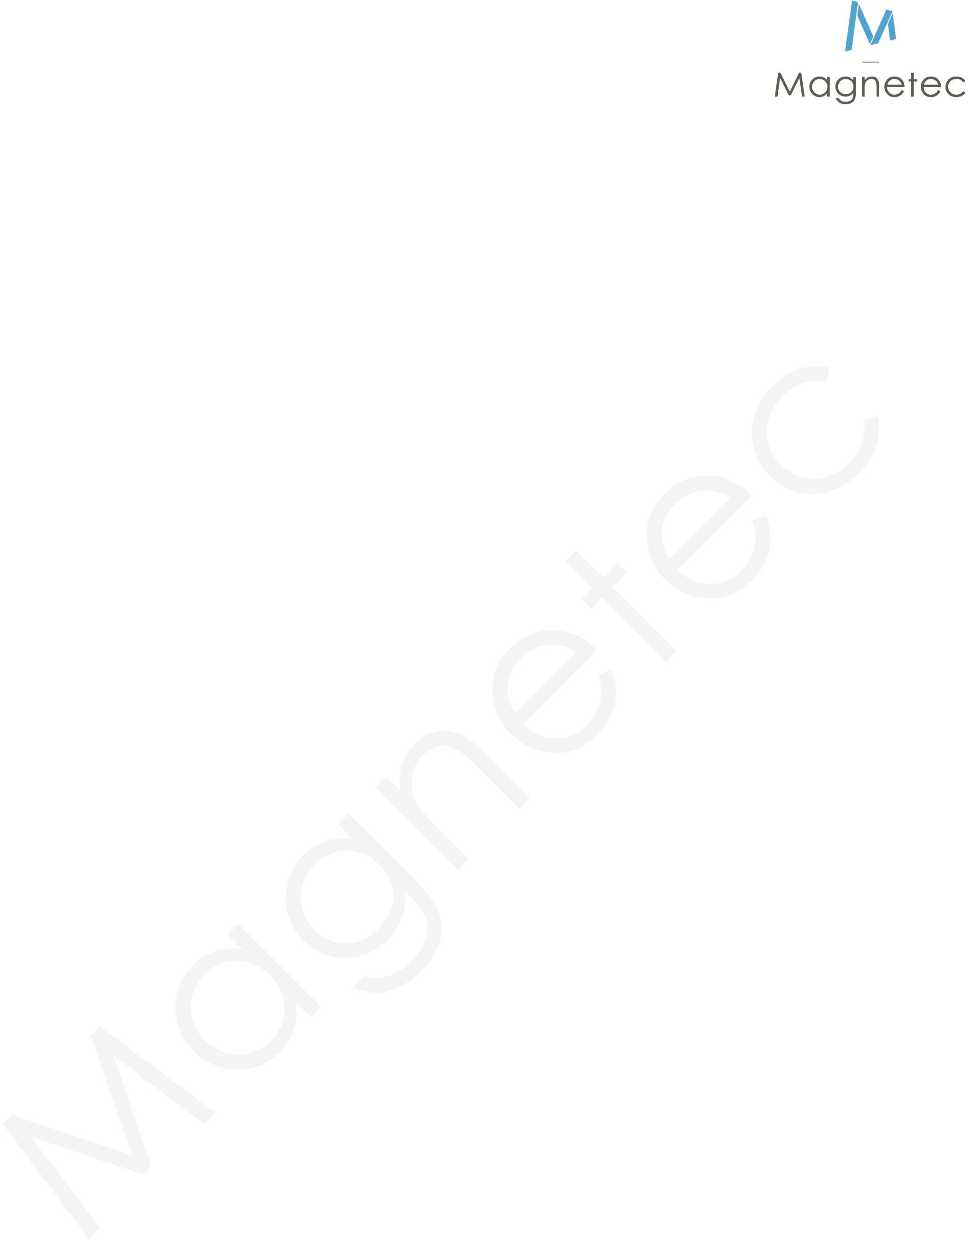In addition to their magnetic performance and efficiency benefits, NANOPERM cores offer other remarkable advantages when compared to ferrite cores:

* Reduced core volume: NANOPERM cores typically require a smaller core volume to achieve the same level of inductance compared to ferrite cores. This reduction in size allows for more compact designs and facilitates miniaturization of electronic systems.
* Lower weight: The compactness of NANOPERM cores results in lower overall weight for chokes and transformers. This advantage is particularly significant in applications where weight reduction is crucial, such as portable electronics or aerospace systems.
* Temperature stability**:** NANOPERM properties are relatively insensitive to temperature changes. This leads to stable values for the core impedance over a wider temperature range, improving the temperature stability of the system over a larger range.
* Improved aging: The magnetic permeability and power losses of ferrites change over time, especially during prolonged operation in higher temperatures. This aging effect is much smaller in nanocrystalline materials.
* Operating Temperature: The Curie temperature of NANOPERM materials is ~600°C; while ferrites have much lower Curie temperatures below 120-200°C. At this temperature, materials lose their magnetic properties. This makes NANOPERM a superior choice in applications where the core can get hot.

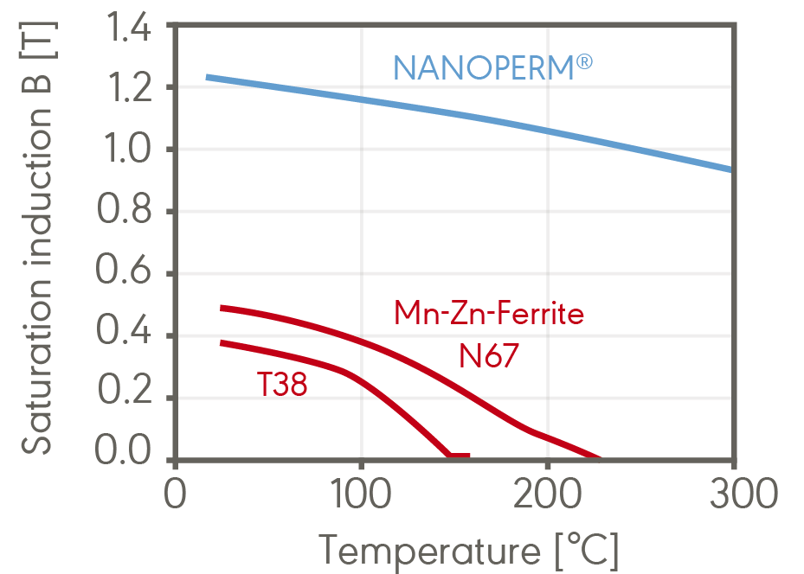

*Fig. 4- NANOPERM’s high Curie temperature allows for operation at much higher temperatures; that is far superior than other materials.*

# 7| Summary

NANOPERM cores and chokes based on this material offer numerous benefits for electronic applications, including:

* High magnetic permeability for more compact solutions.
* Low core losses resulting in enhanced energy efficiency.
* Improved power conversion and system reliability.
* Excellent temperature and aging stability.
* Wide frequency range capabilities for versatile applications.
* Reduced size and weight compared to ferrite, ideal for compact and mobile applications.

In conclusion, NANOPERM cores offer exceptional magnetic properties, low core losses, and high energy efficiency. The key advantages of nanocrystalline cores include high magnetic permeability, low coercivity, high saturation induction, and reduced hysteresis and eddy current losses. These properties result in improved power conversion, enhanced system reliability, and reduced energy dissipation.

NANOPERM cores also exhibit excellent performance across a wide frequency range and offer size and weight advantages compared to traditional ferrite cores, including reduced core volume, lower weight, and higher power density. Overall, NANOPERM cores are an ideal choice for electronic systems.